1. Create linux user with 2 commands:
   1. sudo useradd <user>
   2. sudo passwd <user> (not used by samba) must to unlock user
   3. See all users: cat /etc/passwd
2. Log in as new user to ssh
3. To enable rdp login:
   1. ???
4. You can always become root by (have one test, one pi (root)) :
   1. su - pi
5. Create root folder: sudo mkdir <root>
6. Change owner so can use: sudo chown test:test <root>/
7. Change dir in init python: sudo nano /var/www/html/cli/init-folders.py
8. Run python as <user> : python /var/www/html/cli/init-folders.py
9. Result should look like :

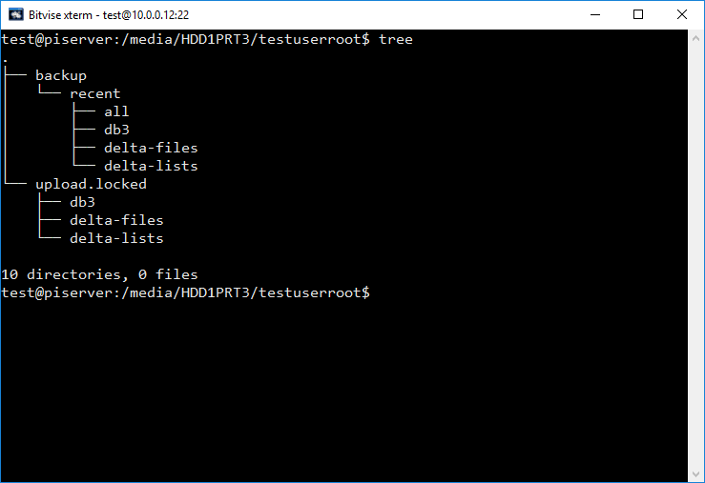

1. Add password for samba : sudo smbpasswd -a <username>
   1. Different from linux! In this example **test** for linux and **test2** for samba
   2. Use very hard one for linux.
   3. Same for resetting password
2. Make samba shares like in example: sudo nano /etc/samba/smb.conf
3. Restart samba: sudo service smbd restart
4. Give secret code (in /var/www/html/db/site.db3 ) our is 7777
5. Upload path in manager: \\piserver\test
   1. So we can add "-upload" or "-backup"
6. Api path : http://piserver/backup-api/
7. Renew credinental with cmd command: net use Z: \\piserver\test-upload\
   1. NOTE: we use this credential so when its mounted its default to those!

Example for smb.conf additions: (in our example all template is all-reserved-01123699)

[test-upload[

path = /media/HDD1PRT3/testuserroot/upload.**unlocked**

valid user = test

read only = no

guest ok = no

browseable = yes

[test-backup[

path = /media/HDD1PRT3/testuserroot/**backup**

valid user = test

read only = **yes**

guest ok = no

browseable = yes

[test-backup-delta[

path = /media/HDD1PRT3/testuserroot/**backup**

veto files = /<all-template>/

valid user = test

read only = **yes**

guest ok = no

browseable = yes

All in one place:

useradd $user

passwd $user

$linux-pass

mkdir /media/HDD1PRT$index/$user-root

python /var/www/html/cli/init-folders.py /media/HDD1PRT$index/$user-root

chown $user:$user -R /media/HDD1PRT$index/$user-root

smbpasswd -a $user

$samba-pass

pi@piserver:/var/www/html/db $ sqlite3 site.db3

.dump users

INSERT INTO "users" VALUES(6666,'Yoni','/media/HDD1PRT3/backup1-root);

.dump users

.quit

Read more about veto files in [here](http://askubuntu.com/questions/14444/how-do-i-blacklist-certain-directories-in-samba).